# UI倒数据任务

查看数据：select pt,count(*) from ysd_merchant_channel_frq_business_report group by pt;

cp /home/cs/python_code/etl/report/data_import_ysd_merchant_channel_frq_business_report.py /home/horae/shell-horae/hivesql

cd /home/horae/shell-horae/hivesql

chown horae:horae /home/horae/shell-horae/hivesql/data_import_ysd_merchant_channel_frq_business_report.py

chmod 755 data_import_ysd_merchant_channel_frq_business_report.py

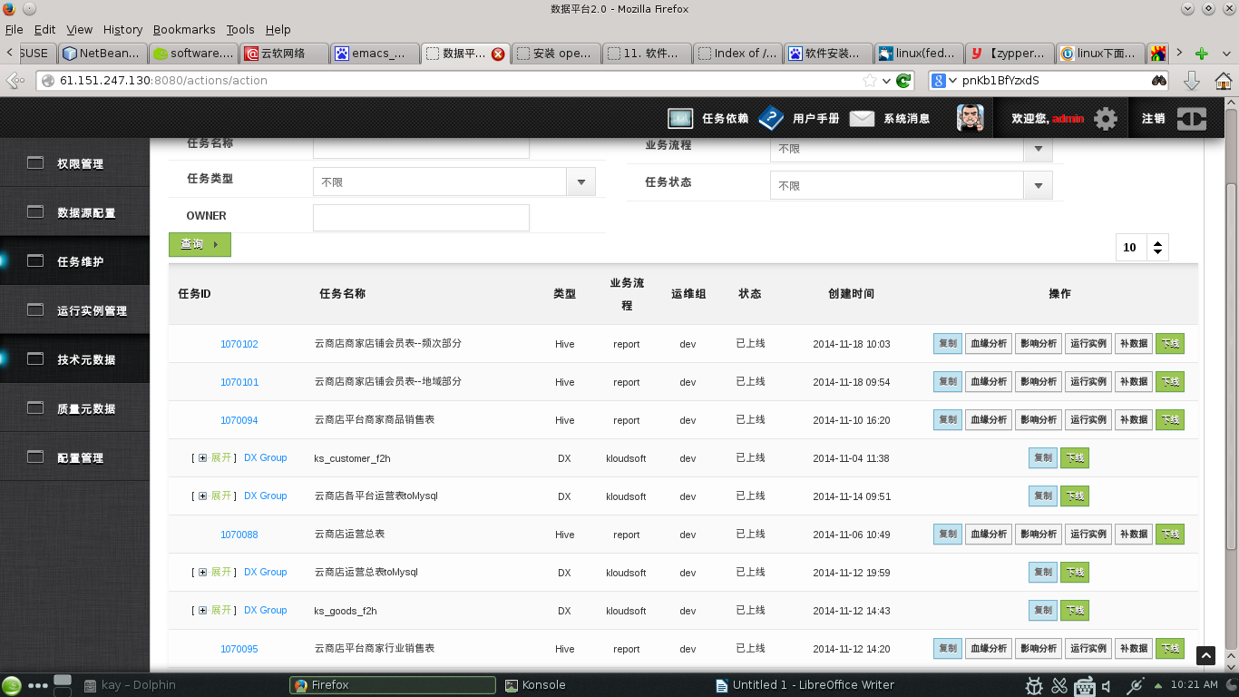

任务维护和运行实例管理

任务维护（添加任务，维护数据）

运行实例管理：查看任务的运行状态及运行日志等。

